Lecture No.30 PARASITOLOGY DR.Raad H.H.
Phylum Microsporidia
Characters:
- about 1000 described species to date; many more to be described
- most species infect invertebrates, especially arthropods. However, some vertebrate hosts also known
- all species parasitic and with intracellular development
- all species produce spores
  - spheroid, ovoid, ellipsoid, or cylindroid
  - trilaminar wall
  - spores usually small, highly refractile, 2-6 micrometers in length; few species with spores up to 20 micrometers in length
  - spores contain an infective sporoplasm that may be uninucleate or binucleate; most sporoplasms lie within coils of polar tube; mitochondria absent
  - spores without a suture or obvious pore
  - contain an extrusion apparatus termed a polar tube; coiled within the spore
  - each spore contains a vacuolar-like organelle termed a polaroplast; this structure is composed of stacks of mebranous tubules
  - polar cap covering attached end of polar tube at one pole of spore
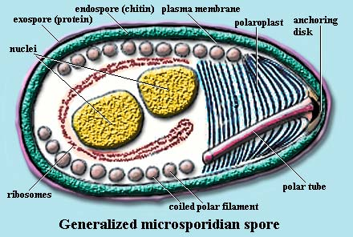
  - posterior vacuole at end opposite the polaroplast

life-cycle :
  - spores ingested
  - polar tube explosively expelled turning inside out; pierces host cell. the polaroplast becomes incorporated as part of polar tube, allowing the polar tube to become considerably larger than in its dormant state
  - sporoplasm rapidly flows through polar tube, effectively injected into a host cell
  - multiple karyokinesis so that large, multinucleate plasmodium formed (asexual reproduction)
  - cytokinesis to form "trophozoites" or "merozoites," analogous to merogony in the Apicomplexa. Essentially, multiple fission
    - some species undergo asexual reproduction more than once
    - some species have 2 closely associated nuclei in each trophozoite; termed diplokarya
  - eventually, formation of multinucelate sporoplasm with nuclei destined to produce spores
  - some, but not all, species have nuclei that undergo meiosis so that haploid nuceli are produced and spores with haploid nuclei. These spores not directly infective for hosts, so a second host is involved where syngamy occurs and other spores produced. Typical genera here include Amblyospora which alternates between mosquitos and copepods .
  - most species have nuclei that remain diploid. Multinucleate (sporogonial) plasmodia formed. This can either involve internal spore formation where areas of cytoplasm become segregated around nuclei, or formation of external pansporoblasts (i.e. budding) that give rise to developing spores separate from main plasmodium.

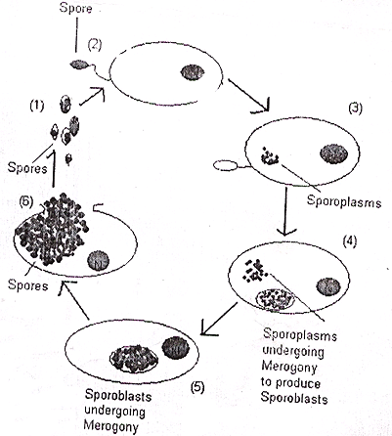

Species known to infect animals and humans :
  - Encephalitozoon cuniculi (disseminates and infects a wide range of mammals host cell types e.g. Rabbits ; hepatitis, keratoconjunctivitis, peritonitis, sinusitis, renal failure, encephalitis etc.; treated with albendazole)
  - Encephalitozoon hellem (disseminates and infects a wide range of host cell types; renal failure, keratoconjunctivitis, pneumonia, etc.; treated with albendazole)
  - Encephalitozoon intestinalis (syn. Septata intestinalis) (disseminates and infects a wide range of host cell types; intestinal involvement, keratoconjunctivitis, sinusitis, osteomyelitis, etc.; treated with albendazole)
  - Enterocytozoon bieneusi (intestinal infection; most common of all microsporidia in humans; no effective treatment although fumagillin analogs show promise; some reports suggest albendazole may have some effect)
- Diagnosis
by taking Biopsy from Bile ,Duodenum , feces , urine or nasal fluid to see G+ve. Spores by Gram’s staining ; Giemsa may used also . SEROLOGICAL TESTS ALSO USED ,IFAT ; MONOCLONAL ; PCR.

The Phylum Ciliophora (ciliata)
Characters :
- Members have Trophozoite large in size and covered by cilia which enable the organism it’s motility.
- Members have 2 nuclei ; Macro nucleus (large ) ,and the Micro nucleus (small).
- most free-living; a few are parasitic.
- Reproduction by conjugation .
Balantidium coli (class: Litostomatea; order: Vestibuliferida)
- cilia over body, with more dense cilia near apical end
- vestibulum (depression) leading into cytostome at apical end
- large macronucleus with small micronucleus
- trophozoites large, up to 150 micrometers in length; yellowish or greenish in appearence
- in colon of swine and primates; some isolates infect guinea pigs, rats, and other mammals
- cysts spheroidal, 40-60 micrometers in diameter (infective stage )
- occasionally can invade mucosa, causing inflammation and ulceration, diarrhea and weight loss
- other members of the genus in invertebrates, fish, amphibia, ostriches, and mammals

" ANAPLASMOSIS"
- Anaplasmosis is a vector-borne, infectious blood disease in cattle caused by the rickesttsial parasites Anaplasma marginale{ most situated on or near the margin of the erythrocyte} , Anaplasma central { most of the organisms are situated away from the margin of the erythrocyte.} and Anaplasma ovis .
- It occurs primarily in warm tropical and subtropical areas.
- The disease is not contagious but is transmitted most commonly by biological transstadial transmission via ticks.
- It can also be transmitted mechanically via contaminated needles, dehorning equipment, castrating knives, tattoo instruments, biting flies and mosquitoes.
- The intracellular parasite destroys red blood cells. It causes anemia, fever, weight loss, breathlessness, uncoordinated movements, abortion and death.
- Diagnosis is based on clinical signs and the examination of blood under microscope for evidence of the parasite {Red colour dense, rounded, intraerythrocytic bodies by Giemsa stain without cytoplasm} .
- Affected cattle either die or begin a recovery within 4 days after the first signs of the disease.
- The mortality rate increases with the age of the animal. Unless infected cattle are detected during the early stages of the disease they should not be treated. If an animal with advanced anaplasmosis is forced to move or becomes excited, it may die from lack of oxygen, also antibiotic treatments do little or nothing to affect the outcome of the disease when given during advanced stages of the disease.
- Treatment consists of the administration of tetracycline.
- A vaccine is available that helps to reduce the severity of the infection.
- If you have any cattle with this disease it is very important to control ticks and follow strict sanitation procedures during vaccinations and other procedures to stop the spread of the disease to healthy animals.
- Animals that recover from anaplasmosis are carriers and can spread the disease.
